Enrolment Walkthrough 2018/19
Students will be asked to log in. They will be sent instructions on how to generate their username and password:
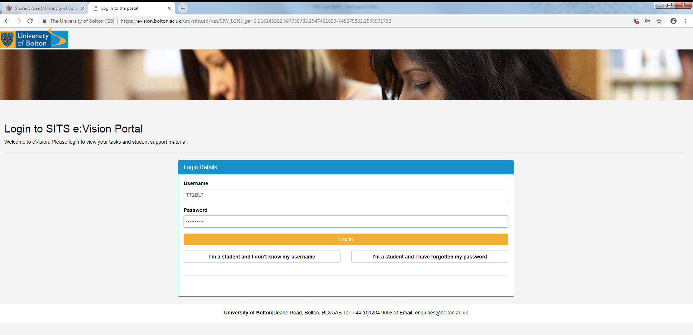
They will then be asked to enter their date of birth:
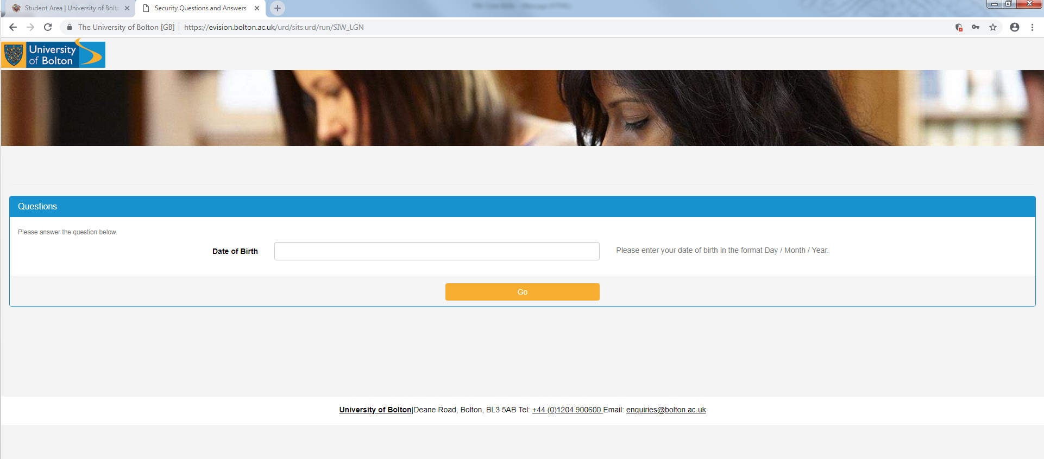
They must select the course from the dropdown list:
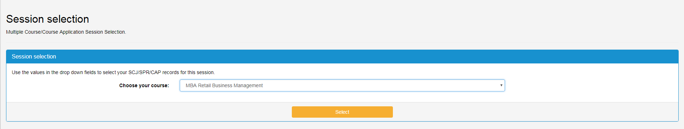

Click enrol next to the course name:
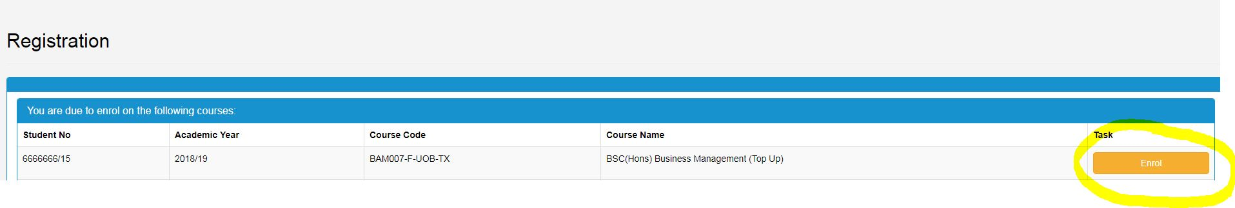
Work through the screens:
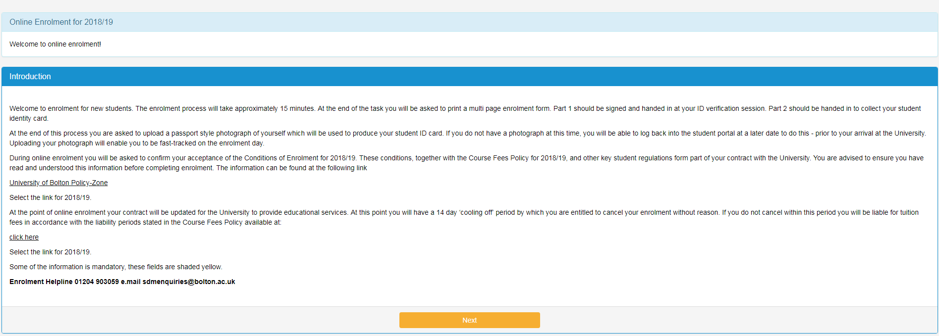
Confirm your name:
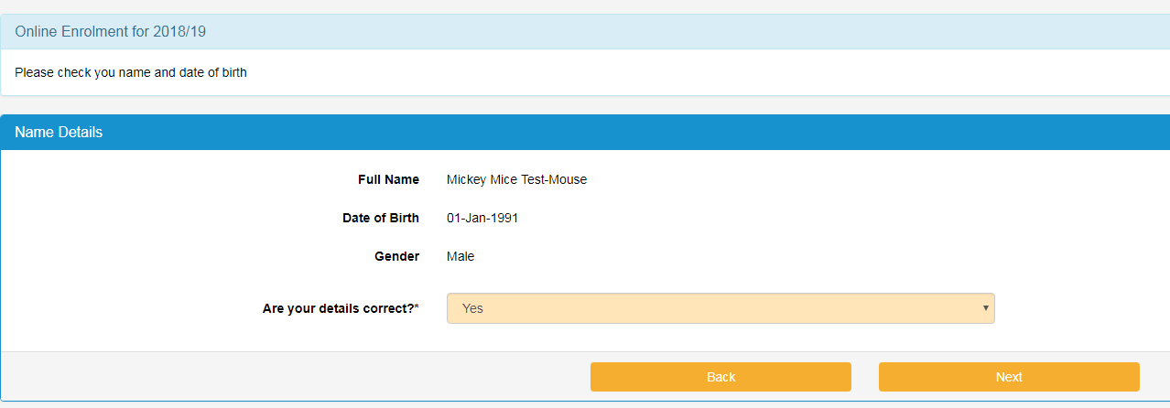
Confirm the course:
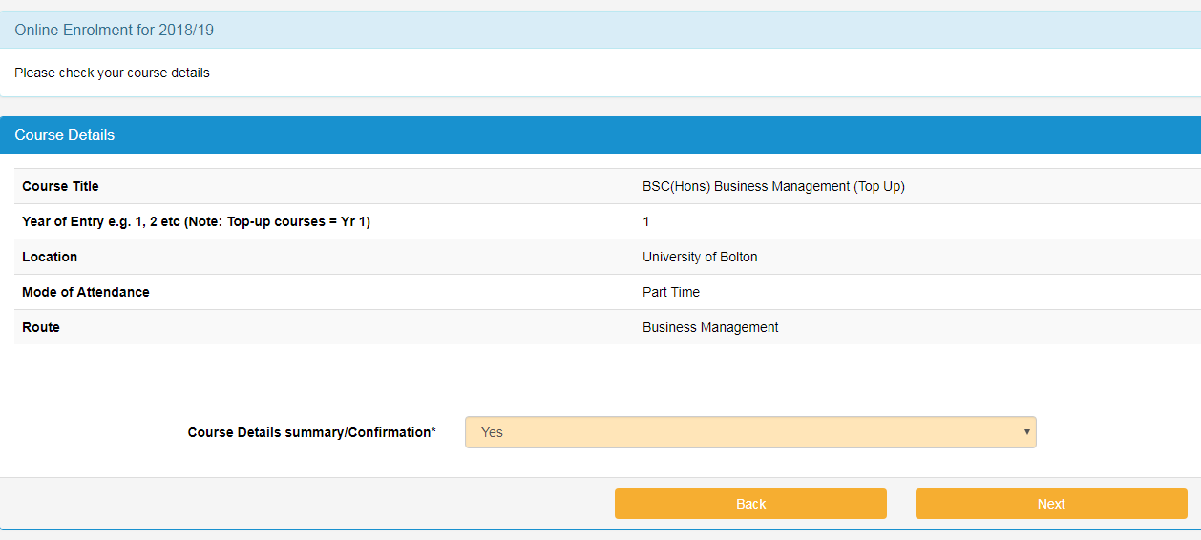
Will you expect to finish the course by the end of July?
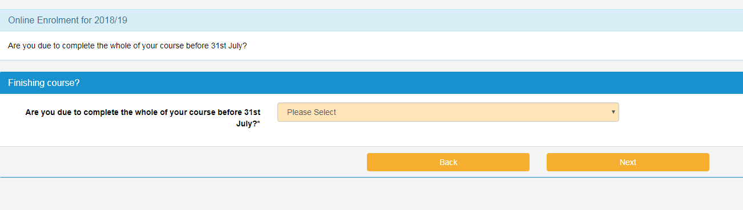
Will you be studying for the whole of the academic year? No if studying a short course:
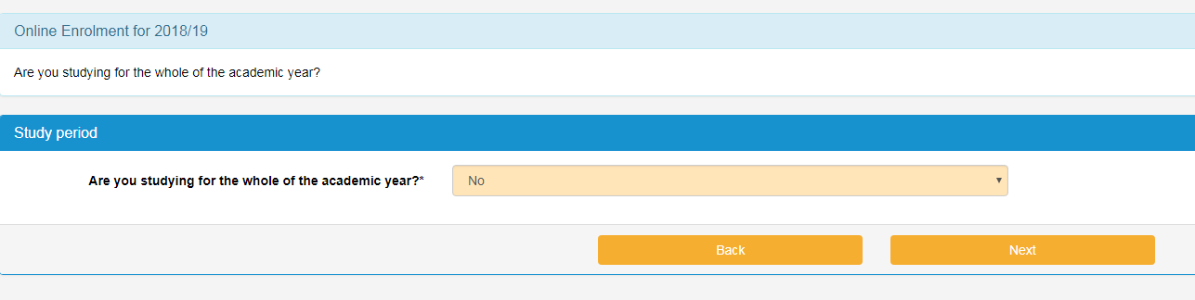
Reason:
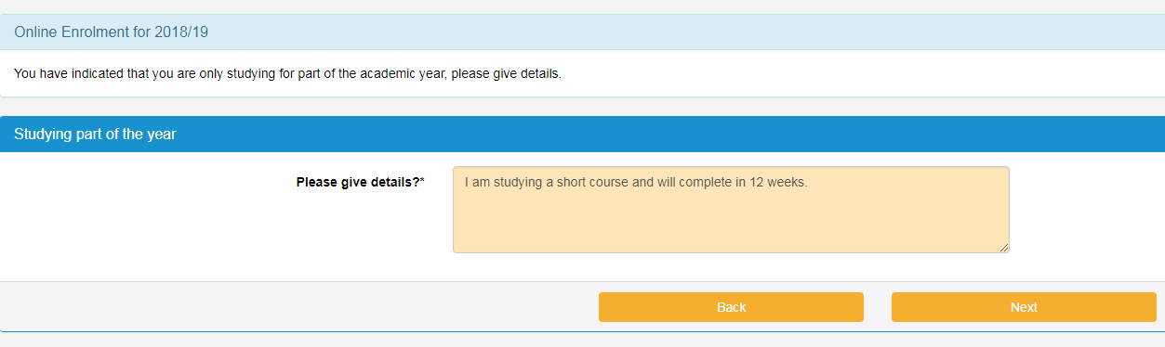

Additional details:
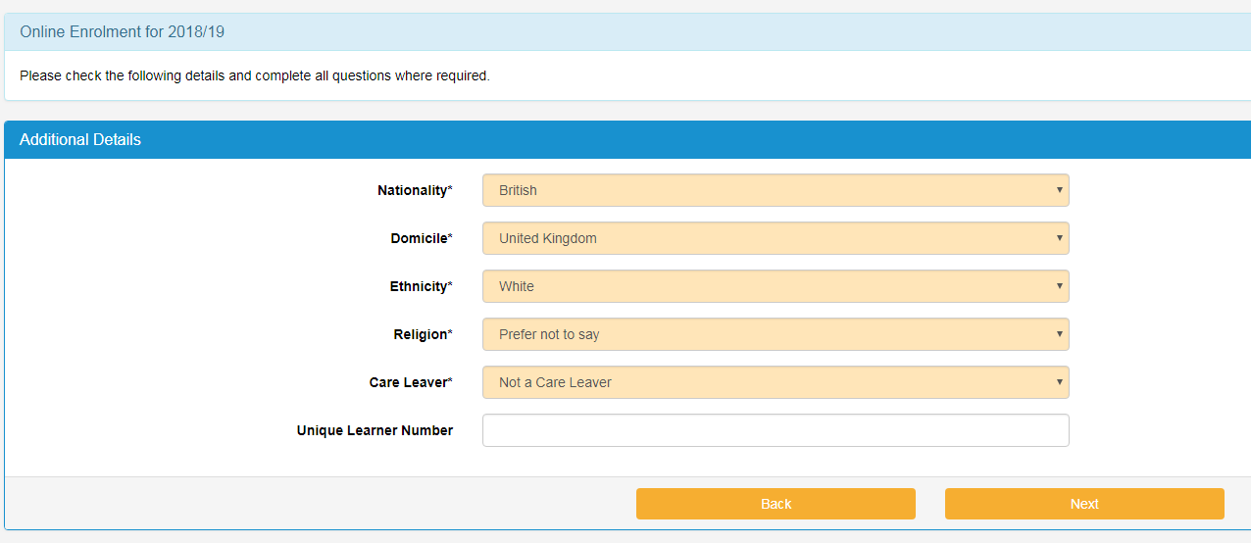
Please leave the unique learner number blank if not known.
Add/Update contact information. Term time address is the address where you are staying whilst studying at university. This could be the same as the home address where you normally reside:
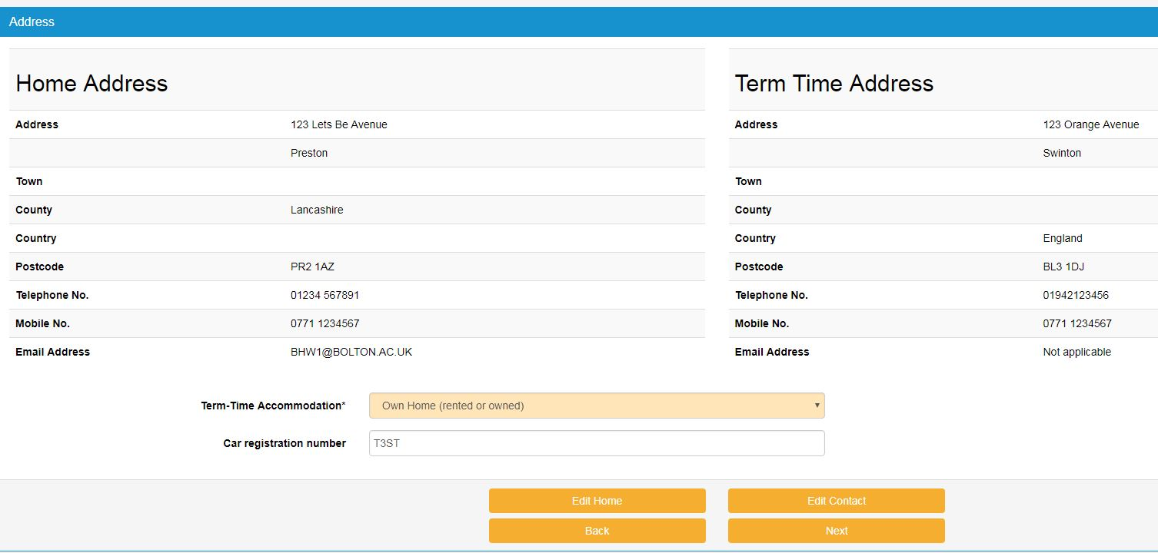
Next of kin information:
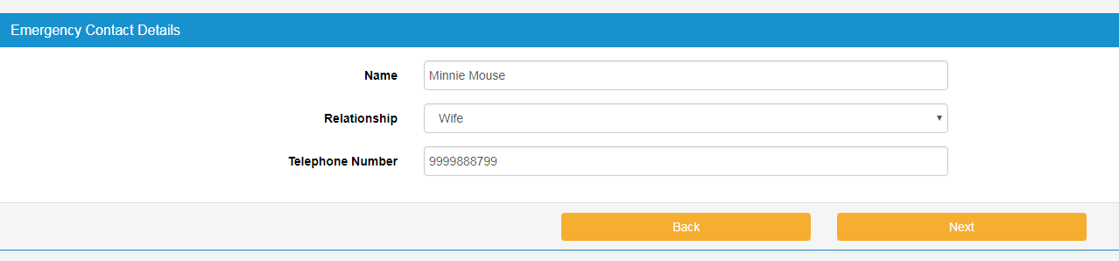
Disability information:
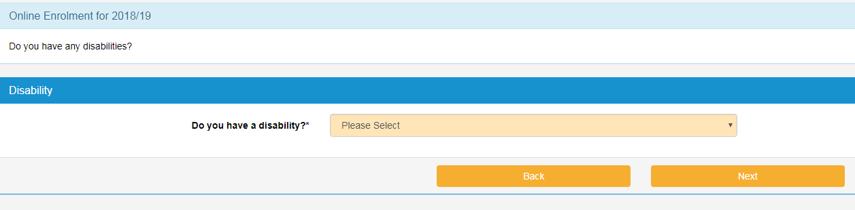
Occupation if you are 21 years old and over. Your parents/guardians occupation (who earns the most) if you are under 21.
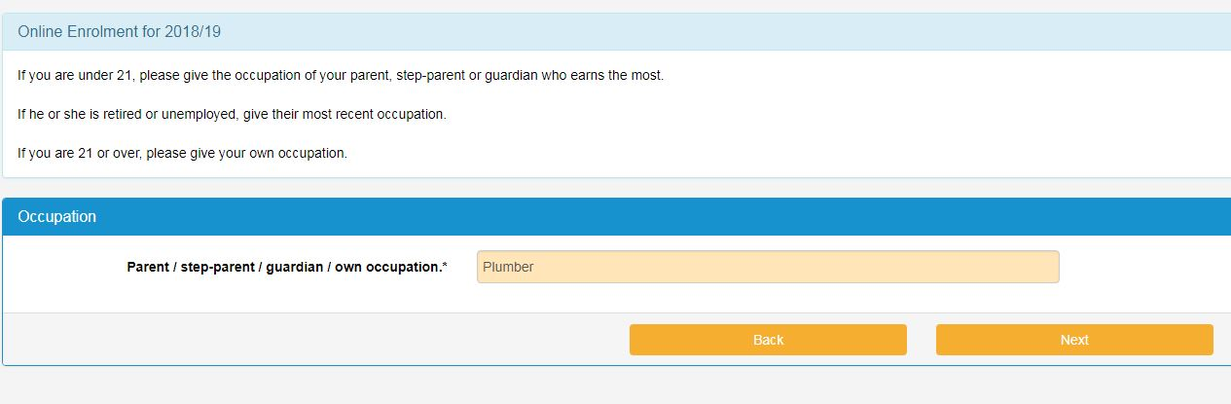
Fee status questions:
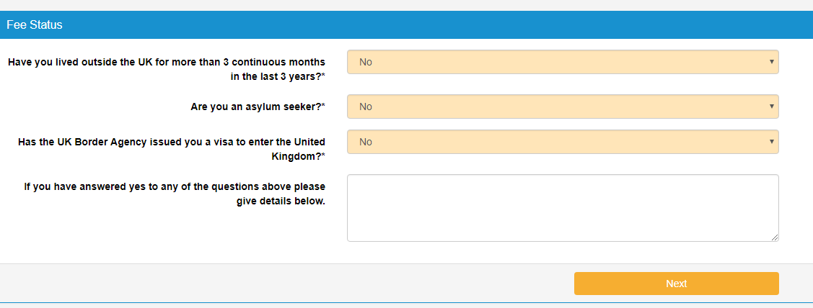

Previous Higher Education Study?
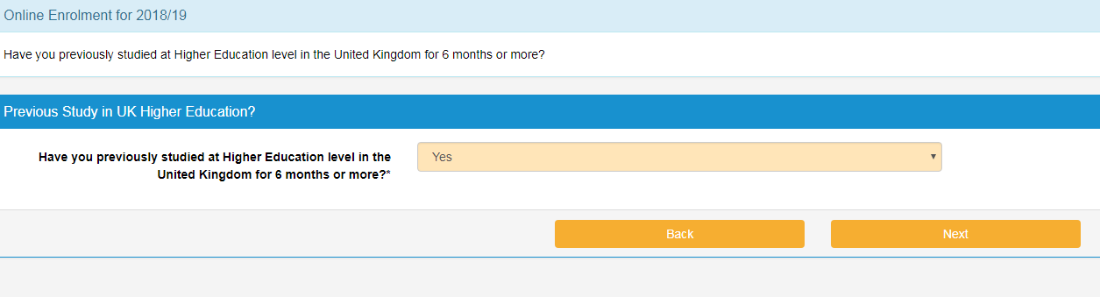
Select your highest level qualification:
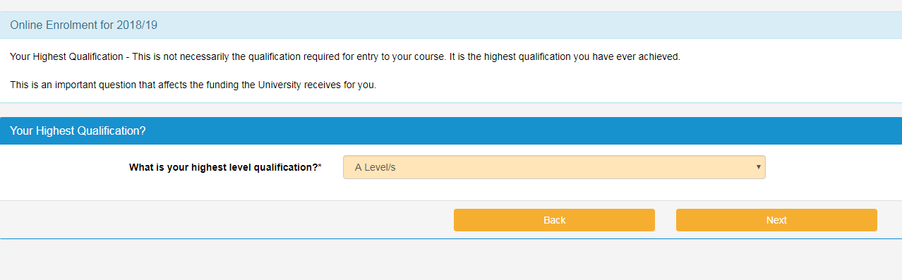
Do any of your parents hold a higher education qualification?
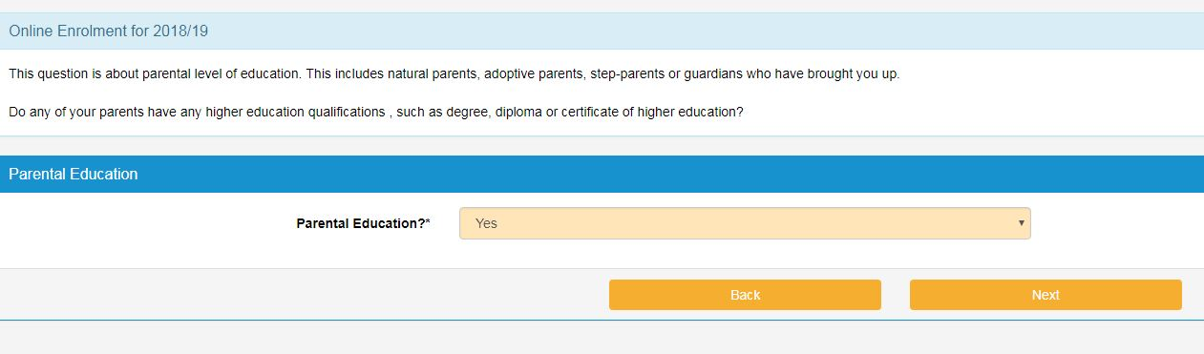

Who is paying for the course?
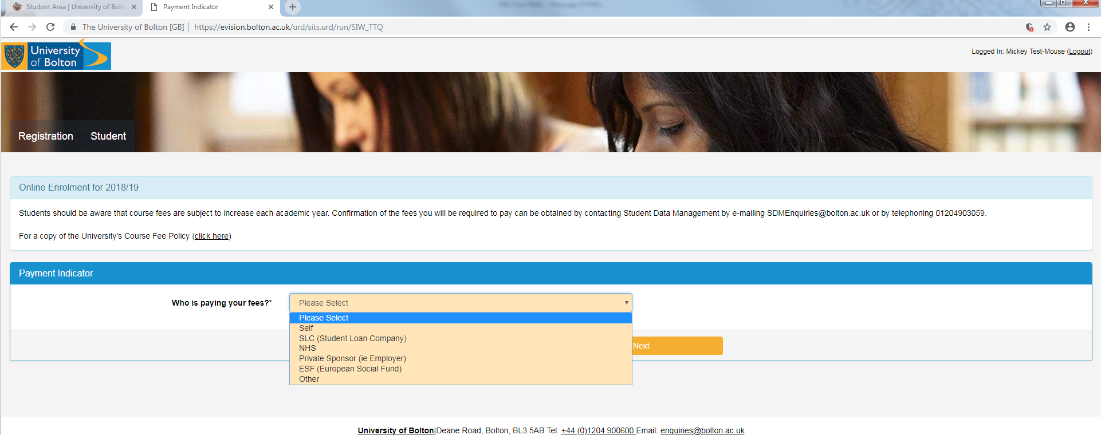
Methods of payment:
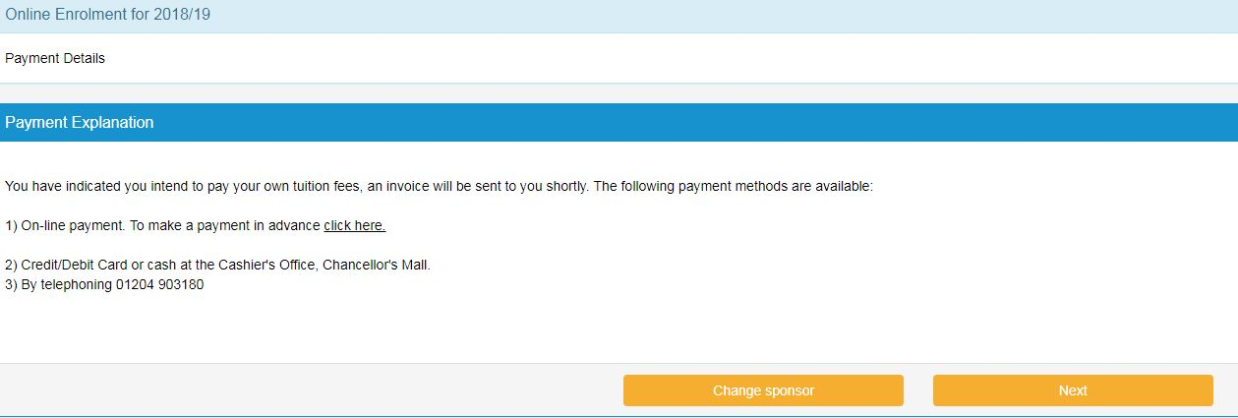
Would you like us to share your basic contact information with our Graduate Recruitment Team and employment agencies?
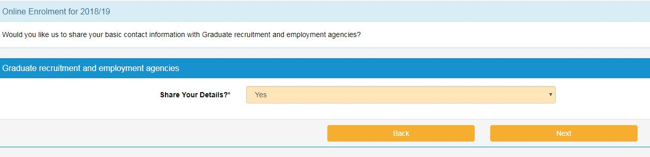

Career questions:
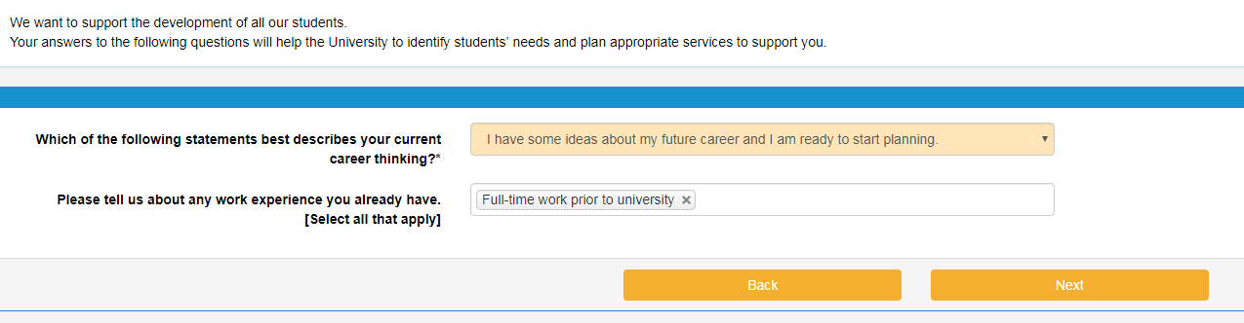
The student will then be presented with the TERMS & CONDITIONS OF ENROLMENT FOR 2018/19 which they must read and decide if they wish to agree to them and continue.
If agreed and they proceed to the next screen they will be enrolled on the course.
They must then print the enrolment form, sign it and attend an ID verification session.

